Project Design Phase-II
Technology Stack (Architecture & Stack)

Date | 04 October 2026
Team ID | SWTID-2026-2511
Project Name | Implement Client Script & UI Policy (Incident)
Team Leader | Ritika L
Team Members | Monisha A, Saranya G, Roshini A V, Yashika K
Maximum Marks | 4 Marks

Technical Architecture:
The Deliverable shall include the architectural diagram as below and the information as per the table1 & table 2
Example: Order processing during pandemics for offline mode
Reference: https://developer.ibm.com/patterns/ai-powered-backend-system-for-order-processing-during-pandemics/
Guidelines:
Include all the processes (As an application logic / Technology Block)
Provide infrastructural demarcation (Local / Cloud)
Indicate external interfaces (third party API’s etc.)
Indicate Data Storage components / services
Indicate interface to machine learning models (if applicable)

Our Technical Architecture: ServiceNow Incident Form with UI Policies & Client Scripts
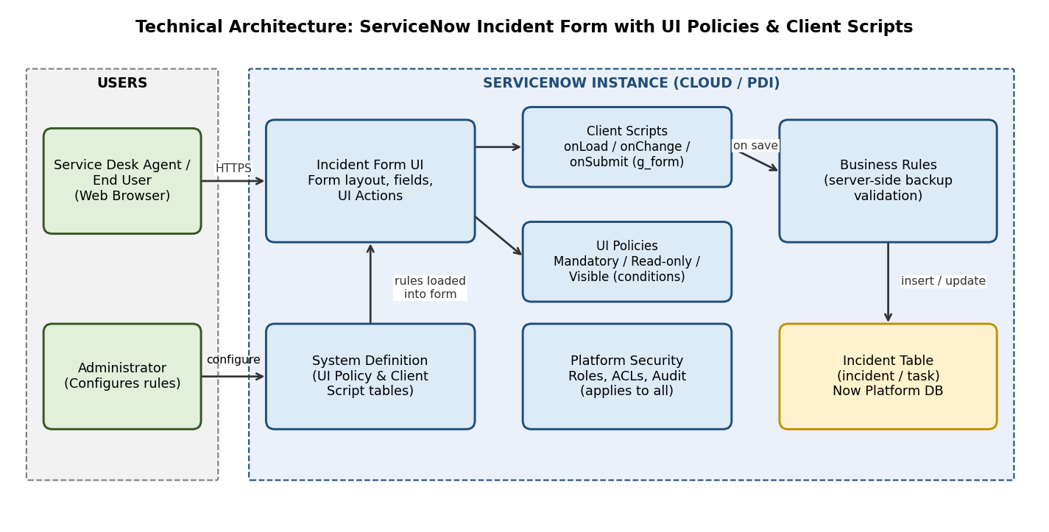

Table-1 : Components & Technologies:
S.No | Component | Description | Technology
 | User Interface | How the user works with the Incident form: ServiceNow web UI in a browser | HTML, CSS, JavaScript (ServiceNow Now Platform form UI)
 | Application Logic-1 | UI Policies on the Incident table: make fields mandatory, read-only or visible based on conditions | ServiceNow UI Policy (conditions and UI Policy actions)
 | Application Logic-2 | Client Scripts for dynamic behaviour: onLoad, onChange and onSubmit | JavaScript with g_form and g_user client APIs
 | Application Logic-3 | Server-side validation as a back-up for the client-side rules | ServiceNow Business Rules (server-side JavaScript)
 | Database | Incident records (incident table, extends task) and the UI Policy / Client Script definitions | ServiceNow Now Platform database (incident, sys_ui_policy, sys_script_client)
 | Cloud Database | Database is managed by the ServiceNow cloud instance | ServiceNow cloud instance (Personal Developer Instance)
 | File Storage | Attachments added to Incident records | ServiceNow attachment storage (sys_attachment)
 | External API-1 | Not used. All logic runs inside the ServiceNow instance | Not applicable
 | External API-2 | Not used in this project | Not applicable
 | Machine Learning Model | Not used in this project | Not applicable
 | Infrastructure (Server / Cloud) | Application is deployed on a ServiceNow cloud instance. Local server configuration: not needed. Cloud server configuration: ServiceNow PDI; changes moved with Update Sets | ServiceNow Cloud, Update Sets

Table-2: Application Characteristics:
S.No | Characteristics | Description | Technology
 | Open-Source Frameworks | No open-source framework is needed; the solution uses ServiceNow platform features and standard JavaScript | ServiceNow platform tools, JavaScript
 | Security Implementations | Role-based access, ACLs and audit on the Incident table and on configuration records; encrypted browser connection; server-side checks back up client rules | Roles, ACLs, HTTPS/TLS, Business Rules, audit
 | Scalable Architecture | Multi-tier platform (browser, application layer, database). Rules are configuration-based and reusable for other tables, so more conditions can be added easily | ServiceNow multi-tier platform, UI Policies
 | Availability | Runs on the managed ServiceNow cloud instance, so no extra servers or load balancers are required | ServiceNow cloud platform
 | Performance | Rules run in the browser, so no page reload or submit is needed. UI Policies are preferred over scripts where possible, and server calls are avoided or made asynchronous | UI Policy, g_form, GlideAjax (asynchronous, if needed)

References:
https://c4model.com/
https://developer.ibm.com/patterns/online-order-processing-system-during-pandemic/
https://www.ibm.com/cloud/architecture
https://aws.amazon.com/architecture
https://medium.com/the-internal-startup/how-to-draw-useful-technical-architecture-diagrams-2d20c9fda90d

